Celebrate your Child’s Birthday with a WILD Party at Billabong Sanctuary!
Three options available to suit your budget:
- BASIC BILLABONG BIRTHDAY BASH
All you pay is discounted entry* to Billabong Sanctuary!

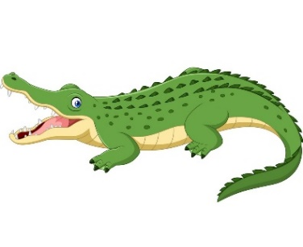
*Discounted entry with a minimum of 10 paid children as follows:
Children $29.70 each (10% saving)

Adults $45.00 each (10% saving)

Family (2a+3C) $132.00 (10% saving)

Reserve a section of the Jolly Jumbuck, or the Coolabah or Poolside seating area, free of charge (Minimum 10 paying children to reserve a picnic area)
If there are 25 or more in your party (adults and children) then reserve Melaleuca Function Centre free of charge!
You’re welcome to decorate your party area, but please, no paper streamers, crepe paper or confetti. Please clean up after the party.
Self-catering: Bring a picnic; you’re welcome to use our free gas barbecues, and we’ll even store
your birthday cake in the fridge for you till it’s time to blow out the candles!

Of course you could also select from the delectable options available in our Blinky Bill’s Cafeteria
-------------------------------------------------------------------------

Optional extras (with a minimum of 10 paying children):
- An hour of Exclusive Animal Interaction: $125
Your Ranger will showcase a variety of cute, cuddly and even slithery animals, with plenty of opportunity for patting and holding. Whenever possible, we will include your child’s favourite animals. Be ready to take some adorable photos! Please book this option a week in advance.
- Face Painting 1 hour for $140.00

Conditions for Basic Billabong Birthday Bash:
Minimum of 10 paid children for discounted entry. Must pay in full as a group, one week in advance.
For bookings please contact mellee.vaughan@gmail.com
2. BEASTLY BILLABONG BIRTHDAY BASH
From $25 per child PLUS Discounted Entry* to Billabong Sanctuary
Includes Animal Interaction and Lunch!
Minimum of 10 paid children for this package. Please book at least 2 weeks in advance.
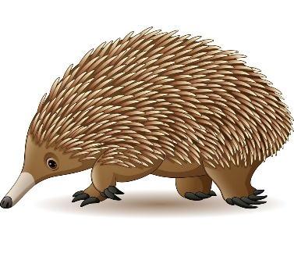
*Discounted entry as follows:
Children $28.05 each (15% saving!)

Adults $42.50 each (15% saving!)

Family (2a+3C) $125.80 (15% saving!)

INCLUDED in the $25/per child cost:
Reserved space in a section of the Jolly Jumbuck, or the Coolabah or Poolside seating area, free of charge
If there are 25 or more in your party (adults and children) then reserve Melaleuca Function Centre free of charge!
You’re welcome to decorate your party area, but please, no paper streamers, crepe paper or confetti. Please clean up after the party.
- An hour of Exclusive Animal Interaction: Your Ranger will showcase a variety of cute, cuddly and even slithery animals, with plenty of opportunity for patting and holding. Whenever possible, we will include your child’s favourite animals. Be ready to take some adorable photos!
- Bag of animal food for each child to feed ducks and kangaroos
- Lunch for the children. Catering options:
1. Hot dogs with sauce & cheese; Fruit Platter to share; Jug of water & jug of cordial
OR
- Nuggets & Chips; Fruit Platter to share; Jug of water & jug of cordial

Please choose one or the other, not both
BYO Birthday cake—we’ll store it in the fridge for you until it’s time to blow out the candles!
----------------------------------------------------
Not included: Entry to Billabong Sanctuary
---------------
Optional extra (with a minimum of 10 paying children):
- Face Painting 1 hour for $140.00
Sometimes our photographer joins the celebration to take photos for our Facebook page. Please let us know if you would agree or would not agree to this.
Conditions for Beastly Billabong Birthday Bash:

Minimum of 10 paid children for this package

Non-refundable deposit of $250 to be paid 7 days before the event.

Payment in full for confirmed number of guests to be made on the day

For bookings please contact mellee.vaughan@gmail.com

3. BEST EVER! BILLABONG BIRTHDAY BASH
From $50 per child PLUS discounted entry* to Billabong Sanctuary
Animal Interaction, Hot Lunch and More!
Minimum of 10 paid children for this package. Please book at least 2 weeks in advance.
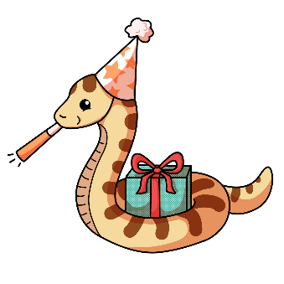
*Discounted entry as follows:
Children $24.75 each (25% saving!)
Adults $37.50 each (25% saving!)

Family (2a+3C) $111.00 (25% saving!)

INCLUDED in the $50 per child cost:
Reserved space in a section of the Jolly Jumbuck, or the Coolabah or Poolside seating area, free of charge (Minimum 10 paying children to reserve a picnic area)
If there are 25 or more in your party (adults and children) then reserve Melaleuca Function Centre free of charge!
- An hour of Exclusive Animal Interaction: Your Ranger will showcase a variety of cute, cuddly and even slithery animals, with plenty of opportunity for patting and holding. Whenever possible, we will include your child’s favourite animals. Be ready to take some adorable photos!
- Bag of animal food for each child to feed ducks and kangaroos
- Group photo presented to birthday child. Each paid child receives a code for a digital copy.
- Wild Party Bag for each child
- Party Food Lunch for Children: (Includes cordial and water)
- Fairy Bread, Bowl of Crisps on arrival
- Party Pies, Cocktail Frankfurters, Chicken Nuggets, Bowl of Hot Chips, Sauces
BYO Birthday cake—We’ll store it in the fridge for you until it’s time to blow out the candles!
------------------------------------------------------------------------
Not included: Entry to Billabong Sanctuary
--------------------------------------------------------------------------
Optional extra (with a minimum of 10 paying children):
- Face Painting 1 hour for $140.00
Sometimes our photographer joins the celebration to take photos for our Facebook page. Please let us know if you would agree or would not agree to this.
----------------------------------------
Conditions for Best Ever! Billabong Birthday Bash:
Minimum of 10 paid children for this package

Non-refundable deposit of $250 to be made 7 days in advance.

Payment in full for confirmed number of guests to be made on the day.

For bookings please contact mellee.vaughan@gmail.com

* * * * *

Please note: If you are celebrating a birthday with a group of fewer than 10 people, we cannot offer the discounted entry rate, but we’ll be happy to store the birthday cake in the fridge for you!

